Recent LOCK-N-STITCH repairs on large steel and cast iron parts

Cracked 18 Ft. diameter crusher table at RMC Cement plant

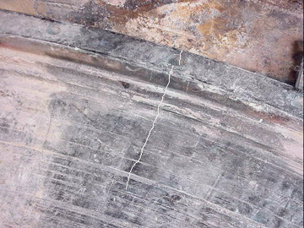
Crack through 10” thick cast iron table.

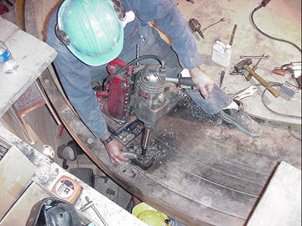
Drilling L60 Lock hole pattern.
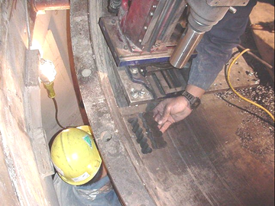
First hole pattern completed

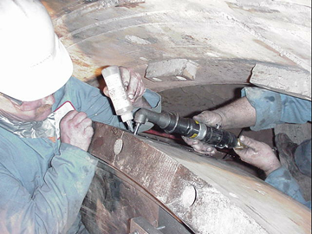
Using special right angle tooling to install C4 pins in tight area.

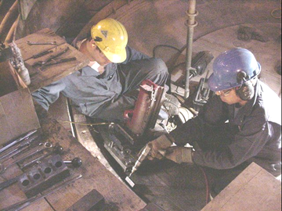
Installing L30 locks in thin area near bolt hole.

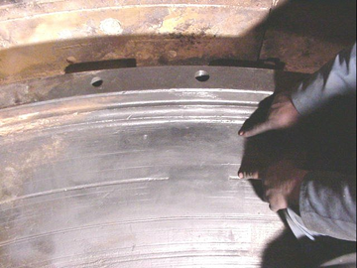
Completed repair. Replacement cost, $800,000.00 repair cost $45,000.00 USD
Repair time 48 hours.

